**Time : 6-7.30 P.M.**

|  |  |  |
| --- | --- | --- |
| **Date** | **Topics** | **Resource Person** |
| **06/07/2021** | Linux: bash script | Prof. Samudravijaya K. |
| **07/07/2021** | Python | Jagabandhu Mishra |
| **08/07/2021** | Google cloud | Dr. Deepak K. T. |
| **09/07/2021** | Pytorch Speaker verification, SQL | Ayush Agarwal &  Samana B S |
| **12/07/2021** | Git , Flask, Scrapy, joblib | Dr. Sishir kalita & Shruti B.S. |
| **13/07/2021** | Airflow, Kubernetes, Docker, Google composer | IIIT Dharwad B.Tech Group |

* Ubuntu installation:

1. Only ubuntu: <https://ubuntu.com/tutorials/tutorial-install-ubuntu-desktop-1604#8-select-your-location>
2. Along With window (dual boot): <https://www.youtube.com/watch?v=4jGQl6SeS2o> (use more than 100 GB (if not possible at least more than 50 GB) space for ubuntu installation )

* Python installation and anaconda :

1. Download miniconda from the link given below: <https://repo.anaconda.com/miniconda/Miniconda3-latest-Linux-x86_64.sh>
2. Open command prompt (ctrl+alt+t) ----> go to the downloaded folder, ex: **cd Downloads** ----->**chmod 777 -R** [**Miniconda3-latest-Linux-x86_64.sh**](https://repo.anaconda.com/miniconda/Miniconda3-latest-Linux-x86_64.sh) ----> **./**[**Miniconda3-latest-Linux-x86_64.sh**](https://repo.anaconda.com/miniconda/Miniconda3-latest-Linux-x86_64.sh)
3. Once the installation finished--->close the terminal by typing **exit** in the command prompt.
4. Open terminal again (ctrl+alt+t)--> **sudo apt install python3-pip**
5. **conda install matplotlib**
6. **conda install spyder**
7. **conda install -c conda-forge jupyterlab**
8. **conda install -c conda-forge notebook**

* **Linux: Bash Script (Prof. Samudravijaya K.** **)**

The primary target audience comprises participants who are new to the Linux environment.

The session will be a tutorial in nature, and includes practicals. All participants are required to work on the linux machine while the session is going on. You will be asked to 'open terminal, execute commands, use gedit editor to write/edit script (text) files, execute script files etc.'. The second part of the session would be visual inspection and understanding of a few bash scripts (used in practical sessions of ASR using Kaldi). So, this session will also help those who are not Linux experts.

@participants who are new to linux OS:

It is imperative to install linux operating systems on a bootable partition ( and not as a virtual environment ) on their PC/laptop. Information about installation of linux has already been shared with you on Tuesday. The relevant para is reproduced below:

Ubuntu installation along With window (dual boot):

https://www.youtube.com/watch?v=4jGQl6SeS2o (use more than 100 GB (if not

possible at least more than 50 GB) space for ubuntu installation )

The successful installation of Linux may take 1 or 2 days. So, it is better to start the installation process today, if you have not done so already. In case you have difficulties, seek help from 'linux experts' whom you know.

If you are new to linux, during the pre-requisite sessions, it would be good [A] to sit by the side of another participant who has some exposure to linux. This is a virtual SS, and this session is in the evening. So, if [A] is not possible, at least be in touch with a friend with linux experience so that you can clear your doubts on the spot.

* Python tutorials:

For basic understanding of Python programming:

1. Please refer to the series of lectures present in the link: <https://spoken-tutorial.org/tutorial-search/?search_foss=Python+3.4.3&search_language=English>. The online tutorial consists of 39 video lectures of approx. duration of 5-10 min duration. After completion of the lectures it is expected that the participants are comfortable with the installation of basic packages to run the python programmes (better to use the ubuntu platform with version 16.0 or earlier) and also comfortable to deal with variables (different data types), loop, functions, classes and plots etc.
2. After successful completion of this basic tutorial, participants have to go through a slightly advanced online tutorial named ‘*Introduction to Python Programming***’** offered in *udacity*, which is a free online tutorial, participants can avail it only by registering in *udacity*. Weblink for the tutorial is: <https://classroom.udacity.com/courses/ud1110>.

* After completing all the package installation, download the attached **Basic_python_tutorial.ipynb** file. After downloading, open terminal and type---> jupyter notebook---> open **Basic_python_tutorial.ipynb**  and explore by running each cell. (we discuss this in the python tutorial session (most probably be on next sunday/tuesday))

**Google Cloud: (Dr. Deepak K.T.)**

**Speaker verification using Pytorch: (Ayush Agarwal)**

Requirements:

* Jupyter notebook
* Install pytorch, librosa, pyworld, pysptk

------------------------------------------------------------------------------------

* Installation procedure for **pytorch** : <https://www.liquidweb.com/kb/how-to-install-pytorch-on-ubuntu/>
* Installation of **librosa**:

<https://www.geeksforgeeks.org/how-to-install-librosa-library-in-python/>

Open the command prompt on your system and write any one of them.

pip install librosa

sudo pip install librosa

pip install -u librosa

* Installation of **pyworld**:

<https://pypi.org/project/pyworld/>

pip install pyworld

* Installation of **pysptk**:

<https://pysptk.readthedocs.io/en/latest/introduction.html>

pip install pysptk

--------------------------------------------------------------------------------------

References:

* Pytorch full course: <https://youtu.be/GIsg-ZUy0MY>
* Pytorch tutorials (beginners) : <https://pytorch.org/tutorials/beginner/basics/intro.html>

**Git, Flask, Scrapy, joblib: (Dr. Sishir Kalita, Shruti B.S.)**

**Kubernetes, Airflow, Docker, Containers,SQL: (IIIT Dharwad B.Tech group)**

**Docker for Ubuntu : ( Ankitha S Madanbhavi IIIT Dharwad )**

**System Requirements :**

**To install Docker Engine, you need the 64-bit version of one of these Ubuntu versions:**

* **Ubuntu Hirsute 21.04**
* **Ubuntu Groovy 20.10**
* **Ubuntu Focal 20.04 (LTS)**
* **Ubuntu Bionic 18.04 (LTS)**
* **Ubuntu Xenial 16.04 (LTS)**

**To uninstall the older versions of Docker use the following command :**

1. **$ sudo apt-get remove docker docker-engine docker.io containerd runc**

**Steps to install docker:**

1. **To install docker : sudo apt install docker.io**
2. **Enter your ubuntu password to continue the installation .**
3. **To continue [y/n] enter Y to proceed.**
4. **Once the docker installation is complete to check the docker version installed : docker --version**
5. **To check docker is enabled use the command : sudo systemctl status docker**

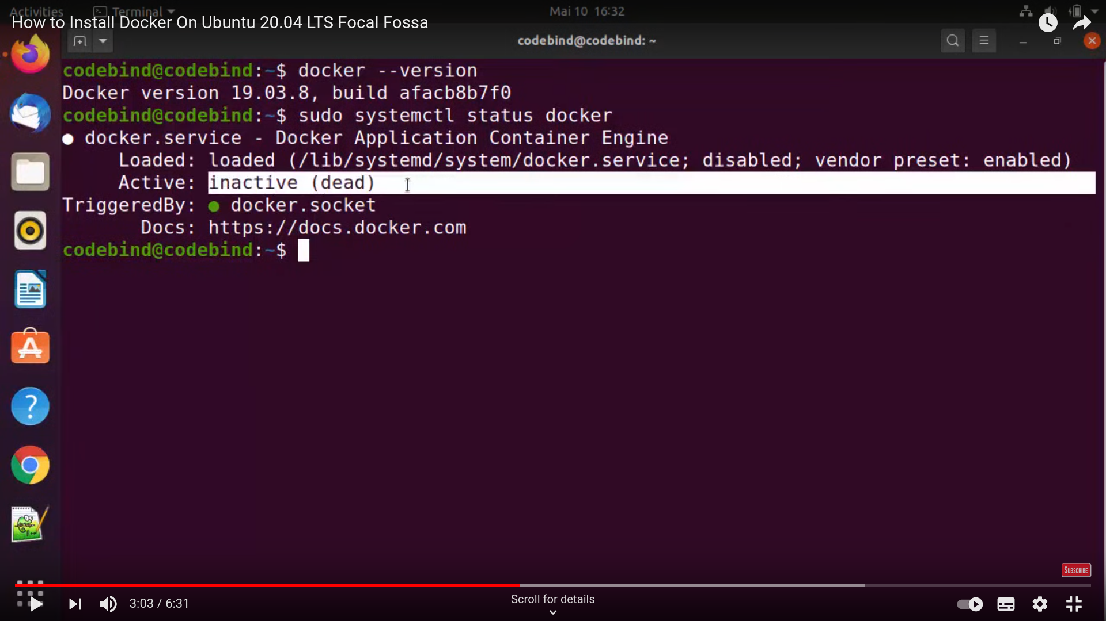

1. **If the status is inactive to convert it to the active mode use the following command: sudo systemctl enable --now docker**
2. **Enter q to exit from the command.**
3. **To ensure docker is running well with docker hub enter the following command: sudo docker run hello-world.**
4. **References :**

**System requirement documentations:** [**https://docs.docker.com/engine/install/ubuntu/**](https://docs.docker.com/engine/install/ubuntu/)

**Tutorial link for installing docker:** [**https://www.youtube.com/watch?v=aMKUuaga85A**](https://www.youtube.com/watch?v=aMKUuaga85A)

**Kaldi: (Shruti B.S.)**

**Requirements: Ubuntu 16.04 and above**

1. Clone Kaldi :  
    In Ubuntu terminal, go to the HOME directory and copy the below command.

git clone<https://github.com/kaldi-asr/kaldi.git>

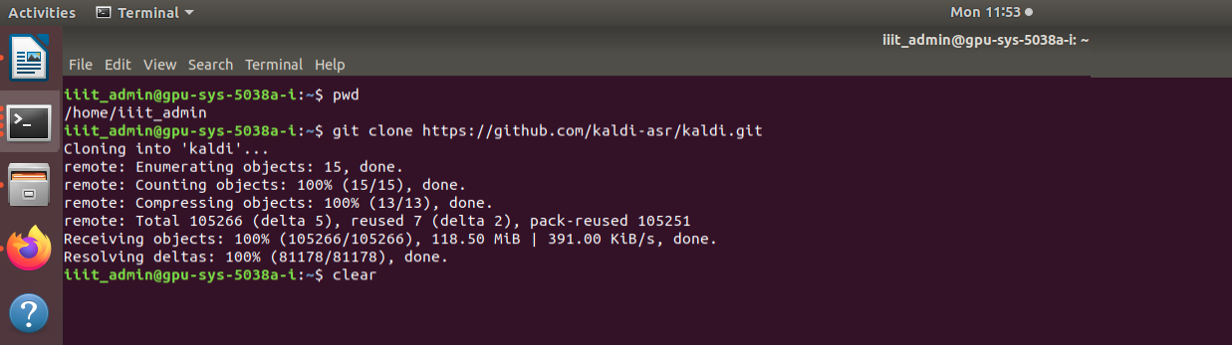

This will clone the Kaldi repository in the HOME directory.

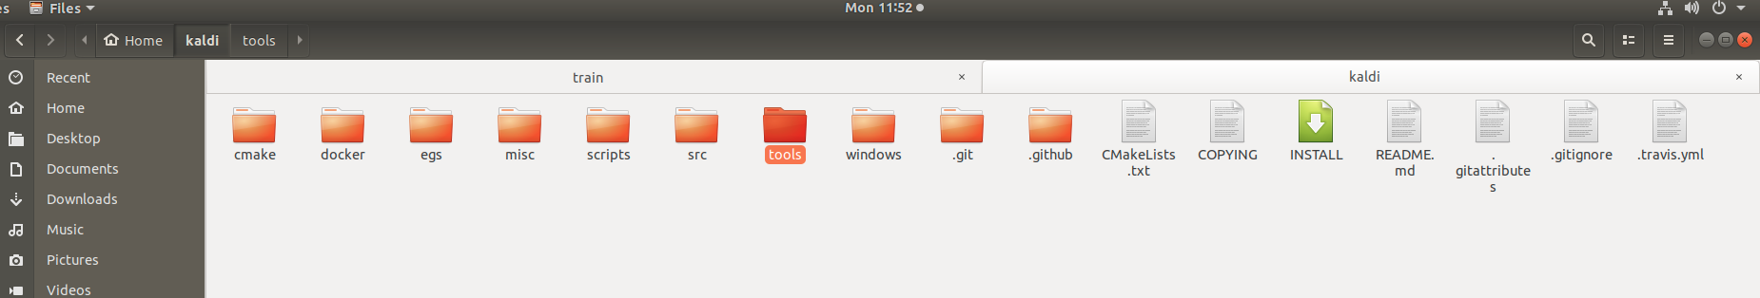

1. Go to the tools/ directory in Kaldi folder and follow INSTALL instructions in the Install file,which are also listed below.

* To check the prerequisites for Kaldi, first run   
   extras/check_dependencies.sh
* It should print ALL OK. (If not follow the instructions in the command prompt to install the dependencies, after that again check extras/check_dependencies.sh, it should print ALL OK )
* Run make

This installs ATLAS headers, OpenFst, SCTK (The NIST Scoring Toolkit) and sph2pipe.

Message got should be All Done OK.

To Install IRSTLM, in terminal type the below command.

extras/install_irstlm.sh

* If you have multiple CPUs you can do a parallel build by supplying the "-j" option to make, e.g. to use 4 CPUs,  
   run make -j 4

3. Go to src/ directory in the Kaldi folder and follow INSTALL instructions in the Install file, which are also listed below.

* ./configure --shared
* make depend -j 8
* make -j 8